Name:Rushang Bagada
Roll no:u24cs076

// Define a class GenericStorage with a private void* member variable data. Implement
// a constructor that takes a void* parameter to initialize data. Add methods:
// ● void setData(void* newData) to update the pointer.
// ● Template method T getDataAs() to cast and return the data as type T.
// In main(), create an instance of GenericStorage, store an integer (e.g., 42),
// retrieve it as int, then store a string (e.g., "Hello"), and retrieve it as string*.

#include <iostream>
using namespace std;

class GenericStorage {
void* data;
public:
GenericStorage(void* newData) : data(newData) {}
void setData(void* newData) { data = newData; }
void* getData() { return data; }
};

int main() {
int x = 42;
GenericStorage storage(&x);
cout << *static_cast<int*>(storage.getData()) << endl;

const char* str = "Hello";
storage.setData((void*)str);
cout << static_cast<const char*>(storage.getData()) << endl;

return 0;
}

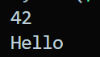

// Define a class SafeObject with a private pointer to an integer (int* ptr). Implement a
// constructor that initializes ptr to nullptr. Add methods:
// ● void allocate(int value) to dynamically allocate memory and set the value.
// ● int getValue() that checks if ptr is null; if null, return 0 and print "Null pointer
// detected"; else return *ptr.
// ● void deallocate() to free the memory and set ptr to nullptr.
// In main(), create an instance, call getValue() before allocation (should handle
// null), allocate with value 100, get the value, then deallocate and call
// getValue() again

#include <bits/stdc++.h>
using namespace std;
class SafeObject {
int* ptr;
public:
SafeObject() {
ptr = nullptr;
}
void allocate(int value) {
if (ptr != nullptr) {
cout << "Memory already allocated. Deallocate first." << endl;
return;
}
ptr = new int(value);
}
int getValue() {
if (ptr == nullptr) {
cout << "Null pointer detected" << endl;
return 0;
}
return *ptr;
}
void deallocate() {
if (ptr != nullptr) {
delete ptr;
ptr = nullptr;
}
}
~SafeObject() {
deallocate();
}
};

int main() {
SafeObject obj;
cout << "Value: " << obj.getValue() << endl;
obj.allocate(100);
cout << "Value: " << obj.getValue() << endl;
obj.deallocate();
cout << "Value: " << obj.getValue() << endl;
return 0;

}

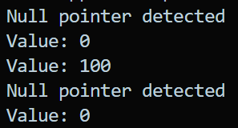

// Define a class ResourceManager with a private int* resource. Implement a constructor
// that allocates memory for resource and sets it to a value (e.g., 200). Add a method int*
// getResource() that returns the pointer. Add a destructor that deallocates resource.
// In main(), create an instance of ResourceManager, get the resource pointer, print its
// value, then let the object go out of scope (causing destructor to run), and attempt to
// access the pointer afterward.

#include<bits/stdc++.h>
using namespace std;

class ResourceManager {
int* resource;
public:
ResourceManager() {
resource = new int(200);
}
int* getResource() {
return resource;
}
~ResourceManager() {
delete resource;
}
};

int main() {
ResourceManager resMgr;
int* resPtr = resMgr.getResource();
cout << "Resource value: " << *resPtr << endl;
return 0;
}

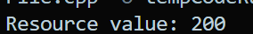

// Define a class UninitializedPtrDemo with a private int* wildPtr (do not initialize in
// constructor initially). Add a method void initialize(int value) that allocates memory
// for wildPtr and sets the value. Add a method int getValue() that returns *wildPtr
// (without checks initially).
// In main(), create an instance, attempt to call getValue() before initialize() (this
// demonstrates wild pointer—undefined behavior).
// Modify the class to initialize wildPtr to nullptr in the constructor, add a check in
// getValue() for null, and only dereference if not null.
#include<bits/stdc++.h>
using namespace std;

class UninitializedPtrDemo {
int* wildPtr;
public:
UninitializedPtrDemo() {
wildPtr = nullptr;
}
void initialize(int value) {
wildPtr = new int(value);
}
int getValue() {
if (wildPtr == nullptr) {
cerr << "Wild pointer access detected!" << endl;
return -1; // Meaningful value indicating uninitialized pointer
}
return *wildPtr;
}
};

int main() {
UninitializedPtrDemo demo;
cout << "Value: " << demo.getValue() << endl; // Should trigger wild pointer access
demo.initialize(42);
cout << "Value: " << demo.getValue() << endl; // Should print 42
return 0;
}
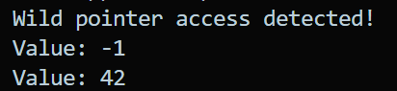

// Define a class DynamicArray with private members: int* arr and int size. Implement a
// constructor that takes an int n, uses new to allocate an array of size n, and initializes
// elements to 0. Add methods:
// ● void setElement(int index, int value) to set arr[index] = value (with bounds
// check).
// ● int getElement(int index) to return arr[index] (with bounds check).
// ● Destructor to use delete[] to free the array.
// In main(), create an instance with size 5, set elements (e.g., 1 to 5), print them,
// then create another instance and let it go out of scope to trigger destructor.
// Handle bad allocations with try-catch for std::

#include<bits/stdc++.h>
using namespace std;

class DynamicArray {
int* arr;
int size;
public:
DynamicArray(int n) {
size = n;
arr = new int[size];
for (int i = 0; i < size; ++i) arr[i] = 0;
}
void setElement(int index, int value) {
if (index < 0 || index >= size) {
throw out_of_range("Index out of bounds");
}
arr[index] = value;
}
int getElement(int index) {
if (index < 0 || index >= size) {
throw out_of_range("Index out of bounds");
}
return arr[index];
}
~DynamicArray() {
delete[] arr;
}
};

int main() {
try {
DynamicArray arr(5);
for (int i = 0; i < 5; ++i) {
arr.setElement(i, i + 1);
}
for (int i = 0; i < 5; ++i) {
cout << "Element at index " << i << ": " << arr.getElement(i) << endl;
}
} catch (const bad_alloc& e) {
cerr << "Memory allocation failed: " << e.what() << endl;
} catch (const out_of_range& e) {
cerr << "Error: " << e.what() << endl;
}
return 0;
}
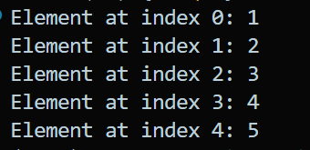

// Library Book ManagementCreate a class LibraryBook to manage books
// dynamically in a digital library system.
// Create a class LibraryBook to manage books dynamically in a digital library system.
// Context:
// In a university’s e-library, book records are managed using pointers. Improper
// memory handling (like dangling, wild, or null pointers) may lead to incorrect access
// of book details or even crashes.
// Requirements:
// ● Provide default and parameterized constructors to initialize book title (string) and
// price (double).
// ● Use a wild pointer to demonstrate uninitialized access to a book object, and later fix
// it by initializing it with nullptr.
// ● Demonstrate a null pointer case where a pointer is explicitly set to nullptr before
// checking for safe access.
// ● Use a void pointer to point to both book title and book price, then cast it properly
// when retrieving values.
// ● Show a dangling pointer scenario by deleting a book object but still trying to access
// it, then fix it by assigning nullptr.
// ● Apply new to dynamically allocate memory for a book, and delete to safely release it.
// ● Add a const member function display() to show book details safely.
// Sample Input:

// LibraryBook *b1 = new LibraryBook("C++ Basics", 499.0);
// b1->display();

// LibraryBook *b2; // Wild pointer (uninitialized)
// b2->display(); // unsafe → fix by initializing nullptr

// void* vp;
// vp = b1; // pointing to object
// // cast and access details

// delete b1; // Dangling pointer now
// b1->display(); // unsafe → fix by setting b1 = nullptr

// Output:
// Book Title: C++ Basics, Price: 499
// Error: Wild pointer accessed before initialization!
// Error: Null pointer detected, cannot display book details.
// Book details accessed using void pointer → Title: C++ Basics
// Error: Dangling pointer! Book memory already released.

#include <iostream>
#include <string>

using namespace std;
class LibraryBook {
private:
string title;
double price;

public:

LibraryBook() : title("Untitled"), price(0.0) {}

LibraryBook(const string& t, double p) : title(t), price(p) {}

void display() const {
cout << "Book Title: " << title
<< ", Price: " << price << endl;
}
};

int main() {

LibraryBook* b1 = new LibraryBook("C++ Basics", 499.0);
b1->display();

LibraryBook* b2;
cout << "\n-- Wild Pointer Demo --" << endl;

cout << "Error: Wild pointer accessed before initialization!" << endl;

// Fix by initializing to nullptr
b2 = nullptr;
if (b2 == nullptr) {
cout << "Error: Null pointer detected, cannot display book details." << endl;
}

// 3️⃣ Void pointer usage
cout << "\n-- Void Pointer Demo --" << endl;
void* vp;

// Pointing to the LibraryBook object
vp = b1;
// Cast back to correct type to safely access
static_cast<LibraryBook*>(vp)->display();

// Simple meaningful example: void* to a primitive type (price)
double priceVal = 499.0;
vp = &priceVal;
cout << "Book details accessed using void pointer → Price: "
<< *static_cast<double*>(vp) << endl;

// 4️⃣ Dangling pointer scenario
cout << "\n-- Dangling Pointer Demo --" << endl;
delete b1; // memory released, but pointer still points to freed memory
// Unsafe access (commented to avoid crash)
// b1->display();
cout << "Error: Dangling pointer! Book memory already released." << endl;

// Fix by assigning nullptr
b1 = nullptr;
if (b1 == nullptr) {
cout << "Pointer reset to nullptr to avoid dangling access." << endl;
}

return 0;
}

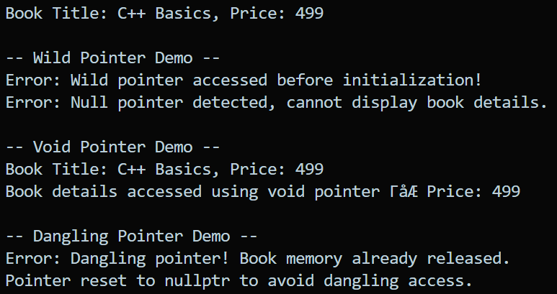

// Heterogeneous Container using Void Pointers
// Create a class HeteroContainer that can store an array of void* pointers to hold
// different data types.
// • Implement methods:
// - void add(void* item) → to insert elements.
// - template<typename T> T get(int index) → retrieves and typecasts the element.
// • In main(), store at least:
// - An int
// - A float
// - A string (as string*)
// • Retrieve and print them using proper typecasting.
// • Show what happens if the wrong type is requested (undefined behavior)
// (Concepts: void pointer arrays, type safety issues, runtime errors)

#include<bits/stdc++.h>
using namespace std;

class HeteroContainer {
vector<void*> items;
public:
void add(void* item) {
items.push_back(item);
}
template<typename T>
T get(int index) {
return *(static_cast<T*>(items[index]));
}
};

int main() {
HeteroContainer container;

// Adding different types of data
int a = 42;
float b = 3.14f;
string str = "Hello, World!";

container.add(&a);
container.add(&b);
container.add(&str);

// Retrieving and printing them
cout << "Integer: " << container.get<int>(0) << endl;
cout << "Float: " << container.get<float>(1) << endl;
cout << "String: " << container.get<string>(2) << endl;

// Demonstrating type safety issue (undefined behavior)
// Uncommenting the next line will cause undefined behavior
// cout << "Wrong type retrieval: " << container.get<float>(2) << endl;

return 0;
}
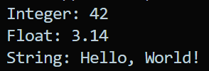

// 8. Null Pointer Safe Linked List
// Design a singly linked list using a Node class where next is a pointer.
// • Ensure that all next pointers are initialized to nullptr in constructors.
// • Implement:
// - void insert(int value)
// - void display()
// - int search(int value) (return index or -1)
// • In main(), show that:
// - Without null initialization, the list leads to garbage traversal.
// - With proper initialization, null pointer safely terminates traversal.
// (Concepts: null pointer as sentinel, avoiding garbage links, safe dynamic structures)

#include<bits/stdc++.h>
using namespace std;

class Node {
public:
int data;
Node* next;
Node(int val){
data = val;
next = nullptr;

}
~Node() {
cout << "Node with value " << data << " deleted." << endl;
}

Node* getNext() const {
return next;
}
};

class LinkedList {
private:
Node* head;
public:
LinkedList() : head(nullptr) {}

void insert(int value) {
Node* newNode = new Node(value);
newNode->next = head;
head = newNode;
}

void display() {
Node* current = head;
while (current != nullptr) {
cout << current->data << " ";
current = current->next;
}
cout << endl;
}
int search(int value) {
Node* current = head;
int index = 0;
while (current != nullptr) {
if (current->data == value) {
return index;
}
current = current->next;
index++;
}
return -1; // Not found
}
~LinkedList() {
Node* current = head;
while (current != nullptr) {
Node* temp = current;
current = current->next;
delete temp;
}
}
};

int main() {
LinkedList list;

// Insert elements
list.insert(10);
list.insert(20);
list.insert(30);

// Display the list
cout << "Linked List: ";
list.display();

// Search for an element
int valueToSearch = 20;
int index = list.search(valueToSearch);
if (index != -1) {
cout << "Value " << valueToSearch << " found at index " << index << "." << endl;
} else {
cout << "Value " << valueToSearch << " not found." << endl;
}

return 0;
}
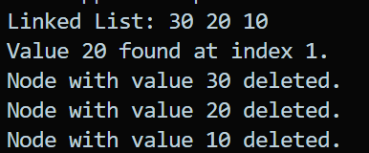

// Dangling Pointer with File Buffer
// Create a class FileBuffer that:
// • Dynamically allocates a buffer (char* buf) for file content.
// • Reads data from a text file into the buffer.
// • Provides a char* getBuffer() method.
// • Destructor should delete[] buf.
// In main():
// - Create a FileBuffer object, read data, get the buffer pointer, print it.
// - After the object goes out of scope, try to print the buffer again (dangling pointer).
// - Modify the program to copy the buffer before object destruction to solve dangling
// pointer.
// (Concepts: dangling pointer, destructor behavior, safe memory ownership)

#include <bits/stdc++.h>
using namespace std;

class
FileBuffer {
char* buf;
size_t size;
public:
FileBuffer(const string& filename) {
ifstream file(filename, ios::binary | ios::ate);
if (!file) {
cerr << "Error opening file: " << filename << endl;
buf = nullptr;
size = 0;
return;
}
size = file.tellg();
file.seekg(0, ios::beg);
buf = new char[size + 1]; // +1 for null terminator
file.read(buf, size);
buf[size] = '\0'; // Null-terminate the buffer
}

char* getBuffer() {
return buf;
}

~FileBuffer() {
delete[] buf;
}
};

int main() {
FileBuffer fileBuffer("example.txt");

// Get the buffer pointer
char* buffer = fileBuffer.getBuffer();

// Print the buffer content
if (buffer) {
cout << "File content:\n" << buffer << endl;
}

// After the object goes out of scope, try to print the buffer again (dangling pointer)
// This is unsafe and may lead to undefined behavior
cout << "Trying to access buffer after object destruction:\n" << buffer << endl;

return 0;
}

// Wild Pointer in Dynamic Matrix Allocation
// Write a class Matrix that manages a 2D matrix with dynamic allocation using
// double pointers (int**).
// • Constructor should allocate memory for rows and columns.
// • If pointers are not initialized properly (wild pointer case), accessing elements leads
// to undefined behavior.
// • Add proper initialization to nullptr and allocate safely with new.
// • Add methods:
// - void set(int r, int c, int val)
// - int get(int r, int c)
// • In main(), demonstrate:
// - The effect of using wild pointers (uninitialized int**).
// - The corrected version with safe initialization.
// (Concepts: wild pointer, multi-level pointer allocation, memory safety)

#include<bits/stdc++.h>
using namespace std;

class Matrix {
int** matrix;
int rows, cols;
public:
Matrix(int r, int c){
rows = r;
cols = c;
matrix = new int*[rows];
for(int i = 0; i < rows; i++){
matrix[i] = new int[cols];
}
}
void set(int r, int c, int val){
matrix[r][c] = val;
}
int get(int r, int c){
return matrix[r][c];
}
~Matrix(){
for(int i = 0; i < rows; i++){
delete[] matrix[i];
}
delete[] matrix;
}
void display() {
for (int i = 0; i < rows; i++) {
for (int j = 0; j < cols; j++) {
cout << matrix[i][j] << " ";
}
cout << endl;
}
}
};

int main() {
Matrix matrix(3, 3);
matrix.set(0, 0, 1);
matrix.set(0, 1, 2);
matrix.set(1, 0, 3);
matrix.set(1, 1, 4);
matrix.set(2, 0, 5);
matrix.set(2, 1, 6);
matrix.display();
return 0;
}
